APPENDIX 1
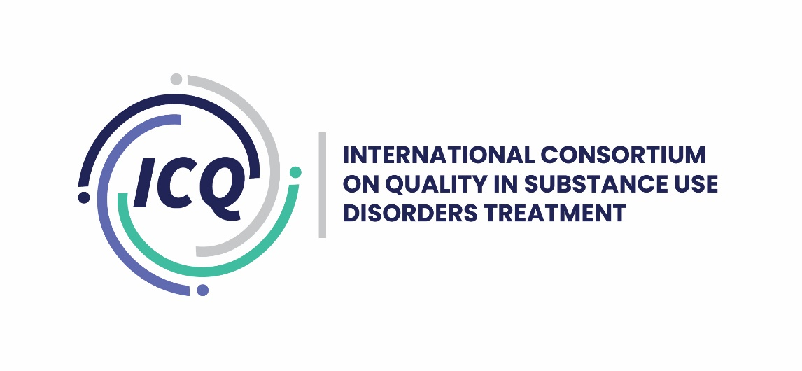

Application Form for ICQ Quality Seal Award for QA organizations

To obtain the quality seal award, an organization’s eligibility is based on their commitment to working towards the achievement of the Quality Seal Award through compliance with the nine standards. They are also committing to annual reports to ICQ Advisory Committee demonstrating action towards that compliance.

There are 3 levels of certification and recognition for organizations applying to obtain the international Quality Seal Award. At each level, an organization is recognized with the provision of a certificate demonstrating their degree of compliance with the nine standards. Each level has a set of prescribed standards and criteria that must be met before moving to the next level. The set of prescribed standards and criteria for each level are color coded in the application form:

- Foundation: an organization has fully demonstrated their compliance with 6 prescribed criteria of the 21 criteria (29% of the total criteria). They can proceed to the next level with annual reports on actions taken to move forward towards the Quality Seal Award.
- Intermediate: an organization has fully demonstrated their compliance with an additional 8 prescribed criteria of the 21 criteria. At this level, organizations have now complied with 67% of the total criteria.
- Quality Seal Award: an organization has fully demonstrated their compliance with the remaining 7 criteria. At this level, organizations have fully complied with all criteria for the Quality Seal Award and can receive the Quality Seal Award certificate

Guidance:
To complete this form, please
- Refer to Section 4 of the Guidance Document for guidance and suggested evidence. The purpose of that section is to assist applicants to complete this form.
- Respond in English or Spanish; and
- For each criterion, please incorporate the specific evidence, and any links being referenced, in the body of your responses. This facilitates the review of the evidence and helps expedite the process.

Section 1: Background
- Organization name
- Organization contact person and job title
- Organization address, e-mail, website, and phone or WhatsApp number
- Country or countries the organization provides quality assurance for substance use disorders treatment services
- Date of application

Section 2: Application questions

STANDARD 1  The QA Organization Supports Implementation of the Principles and Standards Outlined in the ‘International Standards for the Treatment of Drug Use Disorders’ (2020/WHO/UNODC) and ICQ Advisory Committee values. | Criterion 1a: A written statement from the QA organization confirming they agree with the International Standards for the Treatment of Drug Use Disorders (2020, WHO/UNODC).
 | Evidence:
 | Criterion 1b: A written statement from the QA organization confirming they agree with ICQ values.
 | Evidence:

STANDARD 2  The QA Organization has Expertise in Quality Assurance of Substance Use Disorders (SUD) Treatment Services and has Initiatives Underway. | Criterion 2a: The QA organization’s staff or pool of assessors involved in the accreditation process for substance use disorders are competent in SUD treatment.
 | Evidence:
 | Criterion 2b: The QA organization has undertaken accreditation processes with substance use disorders treatment services and keeps a register of such clients (client refers to SUD treatment providers with whom there is a contract or agreement for services).
 | Evidence:

STANDARD 3  The QA Organization’s Standards for Substance Use Disorders Treatment Services are in Line with the ‘Quality Assurance in Treatment for Drug Use Disorders: Key Quality Standards for Appraisal‘, (2021 pre-publication draft) UNODC/WHO, COPOLAD/CICAD (supported by OAS and PAHO), African Union Continental and European Union (EQUS), and supported by EU Drugs Agency. | Criterion 3a: The QA organization attests that their standards are in line with the ‘Key Quality Standards’ (2021, UNODC et al).
 | Evidence:
 | Criterion 3b: The QA organization demonstrates their conformance of the QA organization’s standards with the ‘Key Quality Standards’ (2021, UNODC et al).
 | Evidence:

STANDARD 4  The QA Organization has Standards and Processes for the Registration, Quality Assurance, Accreditation, or Certification of Substance Use Disorders Treatment Services. These Processes are Transparent, Fair and Open to Challenge and are Operated and Applied by Trained and Competent Assessors. | Criterion 4a: The QA organization publishes its QA processes.
 | Evidence:
 | Criterion 4b: The QA organization uses a consistent set of standards and evidence from services to rate services.
 | Evidence:
 | Criterion 4c: The QA organization has an appeals process for services that wish to challenge the scoring or rating they have been awarded.
 | Evidence:
 | Criterion 4d: The QA organization has assessors who are trained in quality assurance.
 | Evidence:

STANDARD 5  The QA Organization’s Quality Assurance Processes Involve Feedback from Treatment Staff and Patients. | Criterion 5a: The QA organization obtains and utilizes patient feedback in its quality assurance processes.
 | Evidence:
 | Criterion 5b: The QA organization obtains and utilizes staff feedback in its quality assurance processes.
 | Evidence:

STANDARD 6  The QA Organization has Established Policies and Procedures to Address Corruption, Unethical Behavior, Conflict of Interest, Illegal Activities and Abuse of Human Rights if Discovered in a SUD Treatment Service. | Criterion 6a: The QA organization has established policies and procedures, including what actions it will take, if it finds corruption, unethical behavior, conflict of interest and illegal activities in a SUD treatment service it is assessing.
 | Evidence:
 | Criterion 6b: The QA organization has established policies and procedures, including what actions it will take, if it finds abuse of human rights in a SUD treatment service it is assessing.
 | Evidence:
 | Criterion 6c: The QA organization will check whether a SUD service provider has systems, policies and processes for preventing and addressing corruption, unethical behavior, conflict of interest, illegal activities and abuse of human rights if it occurs.
 | Evidence:

STANDARD 7  The QA Organization has a Policy and Procedure to Promote Evidence-Based Practice. | Criterion 7a: The QA organization has an established policy and procedure for ensuring the interventions provided by the substance use disorders treatment service are evidence-based and in line with current national and/or international guidance.
 | Evidence:

STANDARD 8  The QA Organization has a Work Plan that Demonstrates Its Ongoing Commitment to the Standards that Underpin the Quality Seal Award Focused on Improving the Quality in Substance Use Disorders Treatment Services. | Criterion 8a: The QA organization has provided a written statement or a work plan reflecting their QA activities to improve the quality of SUD treatment services in line with current international guidelines.
 | Evidence:
 | Criterion 8b: The QA Organization has provided a written statement agreeing to submit an annual report (every 12 months after the ICQ Quality Seal is awarded) of progress made on the written statement or work plan or activities. Where there have been recommendations for improvement, an update on these will be provided as well at this time.
 | Evidence:

STANDARD 9  The QA Organization is Responsibly Governed to Meet its Defined Purpose. | Criterion 9a: The QA Organization is a legal entity and can be held legally responsible for its activities.
 | Evidence:
 | Criterion 9b: The QA organization is effectively managed to meet its strategic objectives.
 | Evidence:
 | Criterion 9c: The QA organization has a defined process in place for the management of ethical concerns and conflicts of interest in the QA organization which is communicated to all staff.
 | Evidence:

